9th September 2019

Dear Parents/Carers

RE: DROP IN SESSIONS – Wednesday 18th September

Welcome back to the new academic year. The children have settled into their new classes really well so far and we would like to take this opportunity to invite you into school to meet the class teachers. This is a short session which will enable you, alongside the other parents of children in the class, to meet the teacher, find out a bit more about your child’s year group and to have a look around their classroom. It is a great opportunity for you to get to know the teachers a little better and to ask any questions you may have.

This is not a parent’s consultation meeting, so the teachers will not be able to discuss individual children in detail at this session.

Our parent consultation meetings will be held in October where you will discuss your child’s progress during an individual appointment with the teacher.

We look forward to welcoming you on Wednesday 18th September between 3:30pm and 4:00pm
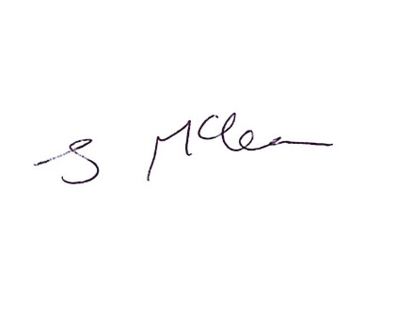
With kind regards

Jenny Mclean
Deputy Headteacher

