21st September 2018

Autumn Term Newsletter
Dear Parents/Carers

Welcome back to Wyken Croft – we are looking forward to working closely with you again this year to ensure every child makes excellent progress. We have had a very positive start to the school year and it has been a real joy to present the first two sets of achievement awards. Should you have any worries or concerns please contact your child’s class teacher in the first instance. Each year group has a year group leader and they are contactable through the office should you wish. Finally, you will have noticed that many of the Senior Leadership Team are at the gates in the morning – please feel free to stop any of us and chat. We hope to see as many parents and carers in school as possible and as such have attached as many dates as we can to help with this.

Macmillan Coffee Morning

On Friday 28th September, our newly appointed Seven Steps Ambassadors will be running a coffee morning to raise money for Macmillan. The coffee morning will be held in the main hall from 10am – 11am and we would be delighted if you could join us.

Website

We are pleased to announce that we are in the process of building a new school website for Wyken Croft.
We are designing this website to provide a comprehensive overview of our aims and values, useful information and resources for pupils.
Our website will always be an evolving work in progress. We will continue to update our website regularly with reports, photo galleries, information regarding your child’s learning and other news from our school.
Keep your eyes peeled for the exciting developments.

From the School Office

The process for applying for Secondary School places has now begun and the closing date for online applications is 31st October 2018 . Please ensure that you make your application before this date as if you make a late application, you will not be included in the first round of allocations in March 2019. The website for applying for Secondary School is www.coventry.gov.uk/schooladmissions but if you are unable to access the internet, please call into school for a paper application or access to a computer.

We are also in the process of implementing a new online payment system called SIMS Agora whereby you will be able to pay for school meals, trips etc., online. This was due to be up and running for the start of term but unfortunately, there was an IT issue during the installation which needs to be resolved. We will send out all the information as soon as we can and thank you for your patience and understanding.

Again can we please remind all our families that the car park is for staff only unless you have a Blue Badge or have been given a pass and permission from Mrs Franklin. We understand the difficulties at the start and end of school when dropping off and picking up your children but are sure that you appreciate the danger in having vehicles driving in and out of the school site at these very busy times. We are also inundated with complaints from local residents of people blocking driveways and dangerous parking. There are also problems when parents stop on Wyken Croft to allow their children to exit their cars causing huge tailbacks and frustration for other commuters. Can we please ask that we all work together in getting the children in and out of school safely each day.

Important Dates

4th October - Under the Sea Special Lunch
8th, 9th & 10th October - Open Evenings
19th October - Non Uniform Day
29th October - Teacher Training Day
1st November - School Photograph Day
21st November - Nasal Flu Vaccinations
7th December - Christmas Fayre
21st December - Christmas Day in a Day

News from EYFS …..

All of the children in EYFS have made a super start to their time at Wyken Croft and we are so proud of the way they have settled in to school routines. We would like to welcome all the new families joining us at Wyken Croft for the first time and likewise those who are returning with a new starter in Early Years. We have been enjoying getting to know your children and finding out all about you as a family, the children’s likes and especially their dislikes! We would like to take this opportunity to thank all of you for being so accommodating on the home visits you have all taken part in. You made us feel very welcome in your homes and they have really helped to make your child’s transition into school a smooth one. We have lots of exciting things to look forward to this term, with the children already beginning to show us what confident, resilient learners they are. Achievement assembly will be starting soon and there will also be some opportunities for you to come into school to share in some learning experiences with your child (more details to follow). We look forward to working with you and sharing your child's learning journey.

News from Year 1 and 2 ……

It has been fantastic to see how well the children have returned to school and settled into their new year groups. The children had a wonderful first few days getting to know their new teachers and developing some of our values through games and activities. It was great to see so many children in assembly with our values postcards. Year 1 have begun their new topic Memory Box and are enjoying thinking about how they have changed since they were babies. Year 2 are using text and their imaginations on an adventure out to sea as pirates in their Topic Land Ahoy. We are really proud of the work the children have produced so far and look forward to welcoming you into school soon to share this with us.
News from Year 3 and 4 …….

What a wonderful start to the year we have had. It has been a delight to see the children come back smiling and ready to start their new adventures! Year 3 have begun the year with the topic ‘Scrumdiddliumptious’; exploring the wonderful world of Willy Wonka. We are all very excited about our trip to Cadbury’s World next week! In Year 4, they have started investigating life in Ancient Roman times in their topic ‘I am Warrior’! Commando Jane has made a super start in Year 4, running sessions with each class every Tuesday morning! Each week the children will work together to complete a mission linked to the Romans. This week’s mission was very exciting! As part of their investigation in to habitats in science they will be exploring Wyken Nature Reserve to look for mini beasts and discover different micro habitats. I know there are many other exciting opportunities coming later on in the term; we can’t wait!

News from Year 5 and 6 ………

It’s been a fantastic start to the year in years 5 and 6. I have very impressed with the way the children have all started the new year with their new teachers. Already we have seen some excellent pieces of work which the children have produced and how proud they are in their work. Year 5 are well into their topic, Vile Victorians, and are looking forward to seeing how the Victorians lived when they visit The Living Black Country Museum. In year 6, the children have settled into their new groups well and are looking forward to learning all about World War 2, incorporating a visit to the amazing Holdenbury House. Keep checking our twitter feed for updates and information about what’s happening in Years 5 and 6.

Enjoy your weekend,

Mrs Franklin
Headteacher

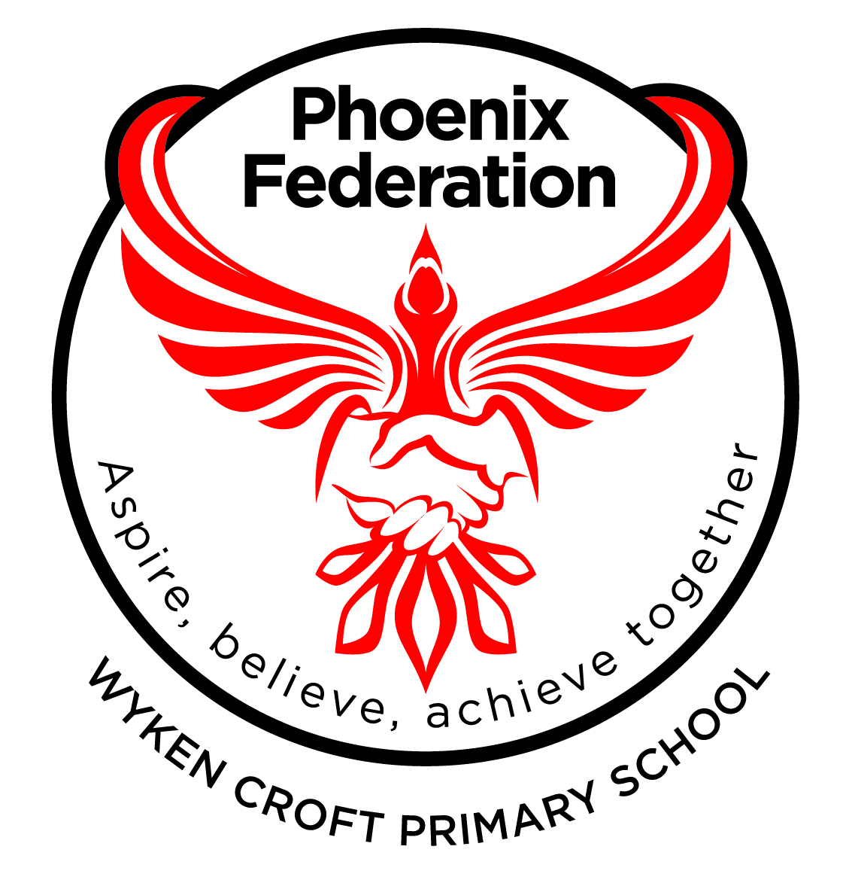

School Terms and Holidays 2018 - 2019

Term | Pupil Dates | Teacher Days
Autumn 2018 | Wednesday 5 September to  Friday 21 December | Monday 3 September  Tuesday 4 September
(Pupil Days ) | Half Term Break  Monday 22 October to  Monday 29 October | Monday 29th October
Christmas Holiday
Monday 24 December to
Friday 4 January
Spring 2019 | Monday 7 January to  Friday 12th April
Total Days -
 | Half Term Break  Monday 18 February to  Monday 25 February | Monday 25 February
Easter Holiday
Monday 15 April to
Friday 26 April
Summer 2019 | Monday 29 April to  Friday 19 July
Total Days -
May Day Holiday
Monday 6 May
Half Term Break
Monday 27 May to
Friday 31 May
 | Summer Holiday Starts  Monday 22 July | Monday 22 July
Total Days
194 + 5 Fixed Teacher Day = 199

Notes:
All Teacher training days have been set by the school and are listed above.

