2nd May 2019

Dear Parents and Carers,

Here at Wyken Croft Primary School we put your child’s safety first; however we are continually concerned about the inconsiderate and often dangerous parking and driving outside of the school and in the surrounding area.

Examples include: drivers mounting the pavement, parking on the single and zigzag lines outside school, parking on double yellow lines which blocks the view for children crossing and also stopping in the middle of the road to let out passengers which disrupts the flow of traffic.

We understand that it is a busy time of day but please try to park further away from the school and walk or leave your car at home as much as possible to walk, scoot or cycle to school. You could take advantage of our walking bus.

The council have the following advice for parents and carers, which is on their website. There may also be a number of enforcement officers in the local area to assist with this matter over the coming weeks and months. Whilst we do not want to cause parents and carers any inconvenience, the safety of your children has to come first.

If you wish to speak to a member of school staff about this matter, please contact Mrs Jenny Mclean (Deputy Headteacher) jmclean@phoenix.coventry.sch.uk 02476613932.

Council Information:

Parking at our schools
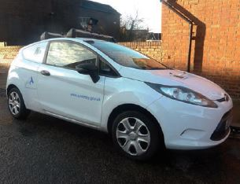
Poor and inconsiderate parking close to schools can place children at risk. Most accidents involving children outside schools occur when a child has their sight obscured by parked cars. Parking restrictions and marked areas on the roads are there for a reason – to keep children safe. The safest option when dropping off or picking your kids up is to park away from the school and take a short walk to the gates.
If you MUST park near to school and space is limited, please follow the rules:
- Do not park on zig-zag lines or keep clear markings
- Do not park across dropped kerbs or drives
- Do not park on footpaths
- Do not stop to drop kids off in the centre of the road
- Always abide by the restriction signs – park only in permitted areas
- Please park safely and be considerate of children and residents by not causing an obstruction

Keeping our children and young people safe
It is hard for us to patrol school gates because we have a limited number of Traffic Wardens and there are a lot of schools. But we can now issue parking tickets using Automatic Number Plate Recognition (ANPR) cameras. We are using a car fitted with an ANPR camera – like the one shown - to drive around the city to issue parking tickets to vehicles we see illegally parked.
People won’t know they have been issued with a ticket until they receive it in the post. But the car will be collecting photographic evidence of illegal parking and the fine will be £70.
With kind regards

Mrs J. McClean
Deputy Headteacher

